Social Media Analytics – Twitter

Social media is not just a platform where people talk to each other, but it has become very vast and serves many more purposes. It has become a medium where people

* Express their interests.
* Share their views.
* Share their displeasures.
* Compliment companies for good and poor services.

So, we can analyze what people are posting on social networks (Twitter) to come up a great application which helps companies to understand about their customers.

**Inputs of the App:**

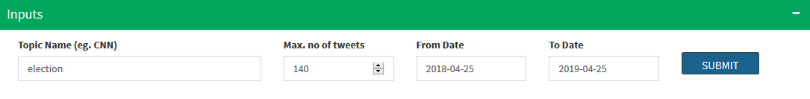

We get a total of 16 variables using ‘userTimeline’ function, snapshot of the sample data is shown below.

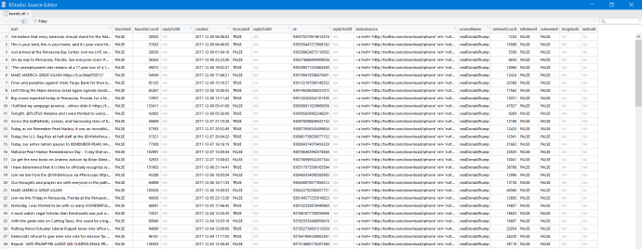

**KPIs for the perticular Hashtag:**



**Top Sources from they are twitted:**

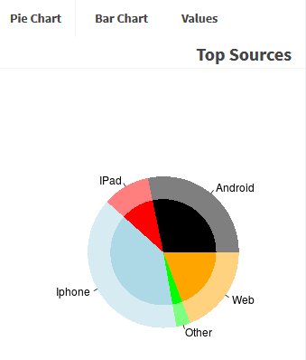 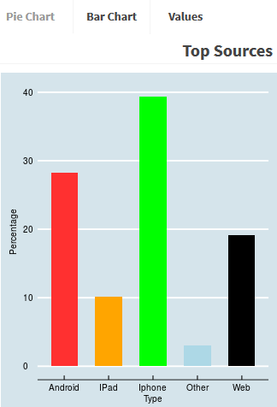

**People emotions to how customers felt about**

Social networks has grown from a mere chatting platform to a storehouse of data which could help companies solve many problems.

Which could help companies understand their customers better. What competitors are doing. Which could help companies understand what customers are talking about it.

The code is divided into following parts:

1. Extracting tweets using Twitter application
2. Cleaning the tweets for further analysis
3. Getting sentiment score for each tweet
4. Segregating positive and negative tweets

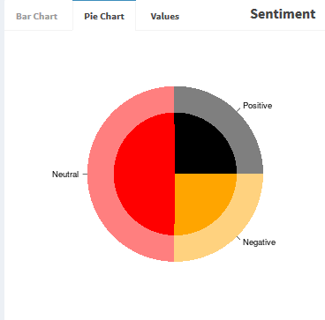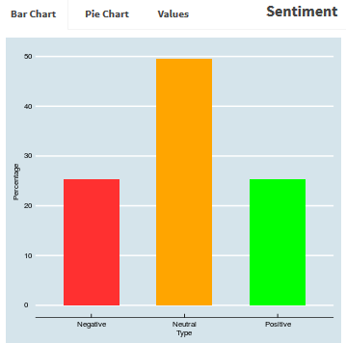

Last few years has been interesting revolution in social media, it is not just platform where people talk to one another but it has become platform where people:

* Express interests
* Share views
* Show dissent
* Praise or criticize companies or politicians

**Top sites from user twitted:**

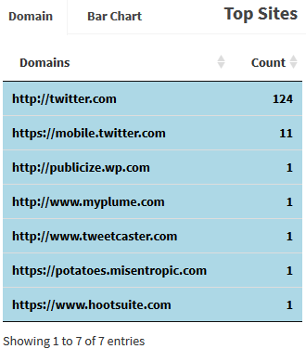 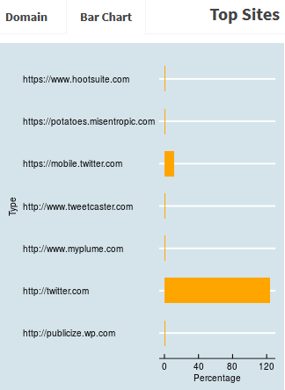

**Share of Posts:**

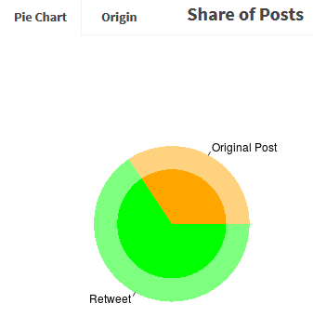 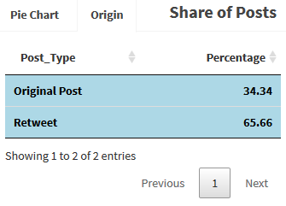

**Top posts and top user for perticular twitter handelled:**

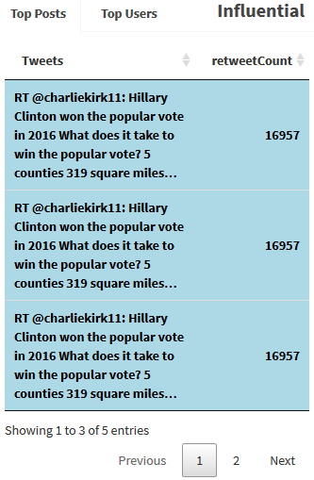 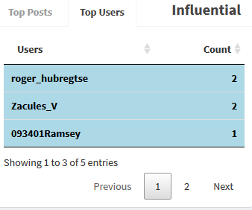

Word cloud is based on document term frequency, that means bigger the word maximum times it has been used. It can be very useful to know some of the insights.

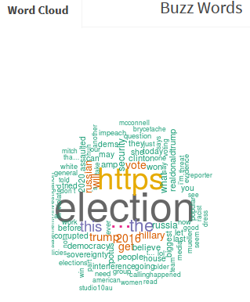

**Sentiment over time:**

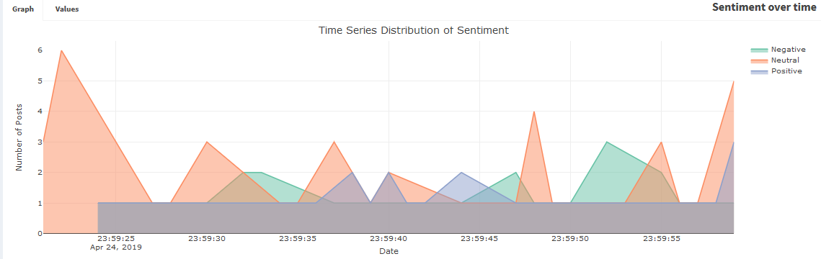

**Phase 1 - Application of Socila Media Analytics**

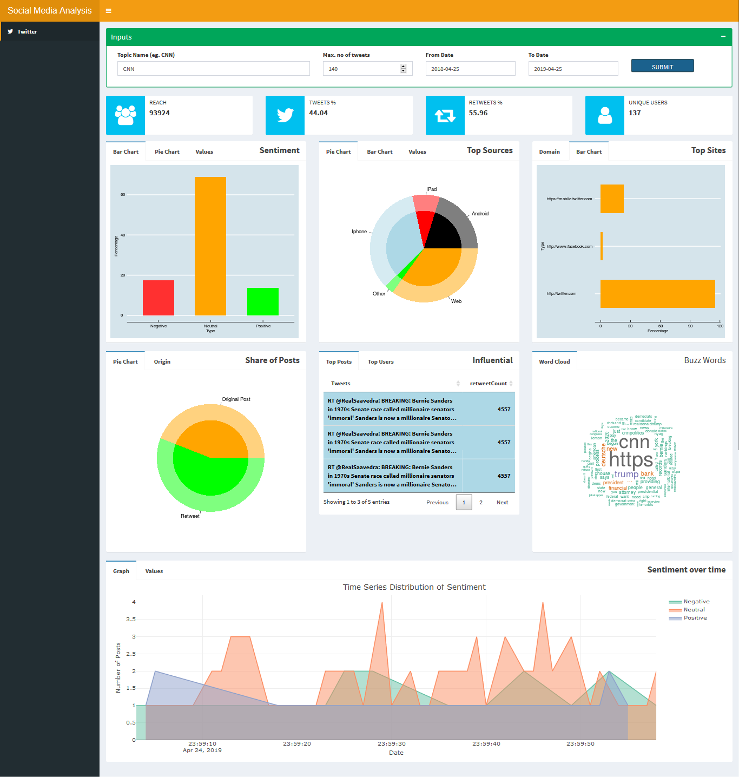

**Note: There are lots of future scope which we can incorporate based on requirements.**